SQL Data Analyst Project

1. 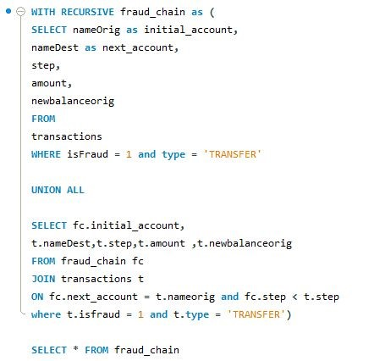**Detecting Recursive Fraudulent Transactions**

**Question:**

Use a recursive CTE to identify potential money laundering chains where money is transferred from one account to another across multiple steps, with all transactions flagged as fraudulent.

**Solution:**

This query uses a recursive CTE to track the flow of money through multiple accounts over successive steps. The recursive part of the CTE allows us to follow the chain of transactions and identify patterns that could indicate money laundering activities. It filters out chains where all transactions are marked as fraudulent.

1. **Analyzing Fraudulent Activity over Time**

**Question:**

Use a CTE to calculate the rolling sum of fraudulent transactions for each account over the last 5 steps.

Solution : This query uses a CTE to calculate the cumulative sum of fraudulent transactions for each account over the last five steps. It helps in understanding the temporal distribution of fraudulent activities, which is crucial for identifying patterns over time.

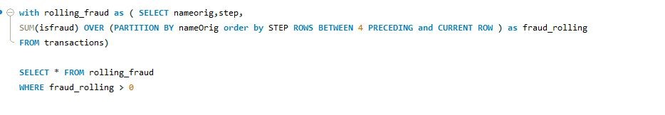

1. **Complex Fraud Detection Using Multiple CTEs**

**Question:**

Use multiple CTEs to identify accounts with suspicious activity, including large transfers, consecutive transactions without balance change, and flagged transactions.

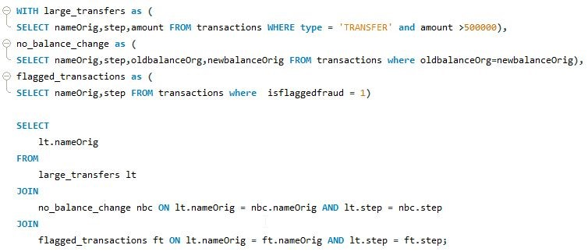

1. **Write me a query that checks if the computed new_updated_Balance is the same as the actual newbalanceDest in the table. If they are equal, it returns those rows.**

